Apol Medrano
Heritage University 11-06-23
Mathematics and Computer Science Dept. Due: 11-12-23

C++
Homework 8
(pointers, dynamic arrays, class )

1. write a grading program for a class with the following grading policies.
Write a grading program for a class with the following grading policies:
a. There are two quizzes, each graded on the basis of 10 points.
b. There is one midterm exam and one final exam, each graded on the
basis of 100 points.
c. The final exam counts for 50% of the grade, the midterm counts for 25%, and the two quizzes together count for a total of 25%. (Do not forget to normalize the quiz scores. They should be converted to a percent before they are averaged in.)
Any grade of 90 or more is an A, any grade of 80 or more (but less than 90) is a B, any grade of 70 or more (but less than 80) is a C, any grade of 60 or more (but less than 70) is a D, and any grade below 60 is an F.
The program will read in the student’s scores and output the student’s record, which consists of two quiz and two exam scores as well as the student’s average numeric score for the entire course and the final letter grade. Define and use a structure for the student record. If this is a class assignment, ask your instructor if input/output should be done with the keyboard and screen or if it should be done with files. If it is to be done with files, ask your instructor for instructions on file names. ch10

//Apol Medrano HW8 Q2
#include <iostream>
#include <cstdlib>
#include <cctype>
using namespace std;
//stucture for keeping record for students performance
struct StudentRecord
{
double quizGrade[2];
double midTerm;
double finalExam;
double avgScore;
char letterGrade;
};
void FindAverageScore(StudentRecord& student);
//takes in studentRecord student, calculates avg score
//assigns value to avgScore and letterGrade
char FindLetterGrade (double classScore);
//takes in avgScoreOfClass
//returns the letterGrade
void checkDynamicSize(int arraySize);
//checks if dynamic array size is illegal
int main()
{
cout.setf(ios::showpoint);
cout.setf(ios::fixed);
cout.precision(2);
char ans;
int studentSize;

do
{
cout << "Amount of Students: ";
cin >> studentSize;
checkDynamicSize (studentSize);
cout << endl;
StudentRecord* student = new StudentRecord[studentSize];

for (int i = 0; i < studentSize; i++)
{
cout << "Student " << i+1 << ":\n";
cout << "Enter quiz 1 score (out of 10): ";
cin >> student[i].quizGrade[0];
cout << "Enter quiz 2 score (out of 10): ";
cin >> student[i].quizGrade[1];
cout << "Enter midterm grade (out of 100): ";
cin >> student[i].midTerm;
cout << "Enter final exam grade (out of 100): ";
cin >> student[i].finalExam;
FindAverageScore(student[i]);
cout << "\nStudent " << i+1 << " score for the class: "
<< student[i].avgScore
<< "\nStudent " << i+1 << " letter grade: "
<< student[i].letterGrade << endl << endl;
}
delete [] student;

cout << "\nWould you like to enter more student grades?"
<< " (Y for yes, N for No): ";
cin >> ans;
} while(toupper(ans) == 'Y');
return 0;

}
void FindAverageScore(StudentRecord& student)
{
double gradeQuiz1 = student.quizGrade[0]/10;
double gradeQuiz2 = student.quizGrade[1]/10;
double gradeMidTerm = student.midTerm/100;
double gradeFinalExam = student.finalExam/100;
double classQuiz = (((gradeQuiz1 + gradeQuiz2)/2) * 100) * .25;
double classMid = (gradeMidTerm * 100) * .25;
double classFinal = (gradeFinalExam * 100) * .5;
double classScore = classQuiz + classMid + classFinal;

student.avgScore = classScore;
student.letterGrade = FindLetterGrade(classScore);
}
char FindLetterGrade (double classScore)
{
if (classScore >= 90)
return ('A');
if (classScore >= 80 && classScore < 90)
return ('B');
if (classScore >= 70 && classScore < 80)
return ('C');
if (classScore >= 60 && classScore <70 )
return ('D');
if (classScore < 60)
return ('F');
}
void checkDynamicSize(int arraySize)
{
if ((!(isdigit(arraySize))) && (arraySize > 0))
return;
else
{
cout << "Invalid input. Aborting program.\n";
exit(1);
}
}
Q1 OUTPUT:
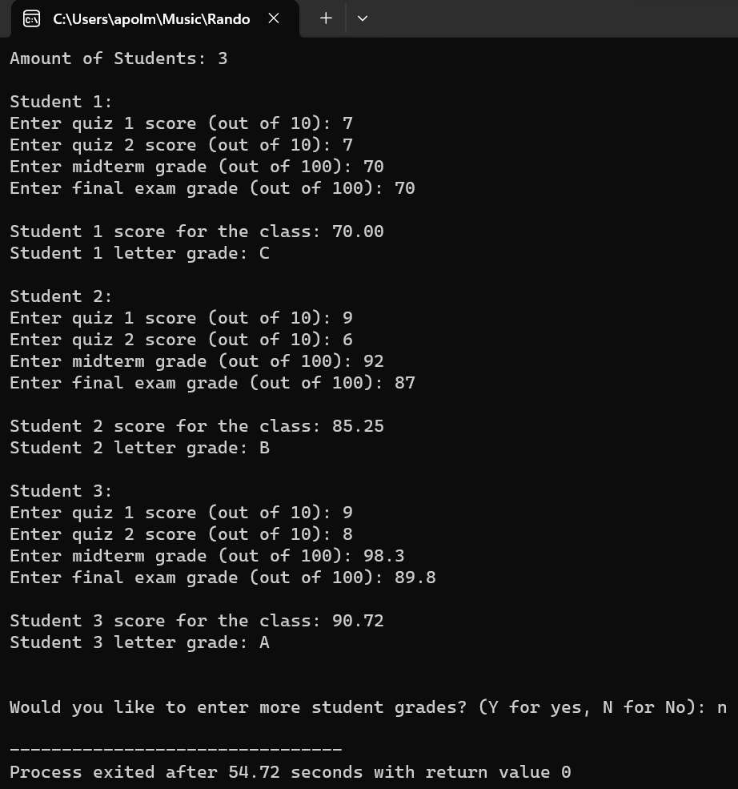

2. Define a class called Odometer that will be used to track fuel and mileage for an automotive vehicle. Include private member variables to track the miles driven and the fuel efficiency of the vehicle in miles per gallon. The class should have a constructor that initializes these values to zero. Include a member function to reset the odometer to zero miles, a member function to set the fuel efficiency, a member function that accepts miles
driven for a trip and adds it to the odometer’s total, and a member function that returns the number of gallons of gasoline that the vehicle has consumed since the odometer was last reset.
Use your class with a test program that creates several trips with different fuel efficiencies. Ch10

//Apol Medrano HW8 Q2
#include <iostream>
#include <cstdlib>
#include <cctype>
using namespace std;
//tracks fuel efficiency and mileage for an automotive vehicle
class Odometer
{
public:
friend ostream& operator <<(ostream& outs, const Odometer& vehicle);
//prints the milesDriven value of an object
Odometer();
//intializes Odometer variables to zero
Odometer(int theMilesDriven, double gasMileage);
//intializes Odometer variables to attached values
void resetOdometer ();
//sets milesDriven to zero
void setFuelEfficiency (double gasMileage);
//sets FuelEfficiency to user inputed value
void addMiles (int theMilesDriven);
//sets milesDriven to user inputed value
double gallonsOfGasUsed ();
//returns the amont of gas used in gallons
private:
int milesDriven;
double fuelEfficiency;
};
void checkDynamicSize (int arraySize);
//checks if dynamic array size is illegal
int main()
{
cout.setf(ios::showpoint);
cout.setf(ios::fixed);
cout.precision(2);

int arraySize, miles;
double gasMileage;
char ans;
Odometer totalVehicle;

do
{
cout << "Trips taken: ";
cin >> arraySize;
checkDynamicSize (arraySize);
cout << endl;

Odometer* vehicle = new Odometer[arraySize];

for (int i = 0; i < arraySize; i++)
{
cout << "Trip " << i+1 << ":\n";
cout << "Enter miles driven: ";
cin >> miles;
vehicle[i].addMiles(miles);
totalVehicle.addMiles(miles);
cout << "Enter fuel efficiency: ";
cin >> gasMileage;
vehicle[i].setFuelEfficiency(gasMileage);
cout << "Gallons of gas used: "
<< vehicle[i].gallonsOfGasUsed()
<< endl << endl;
}
delete [] vehicle;
cout << "Total miles driven: " << totalVehicle
<< "\nReset Odometer? (Y for yes, N for No)\n";
cin >> ans;
if (toupper(ans) == 'Y')
{
totalVehicle.resetOdometer();
}

cout << "\nWould you like to enter more trips?"
<< " (Y for yes, N for No): ";
cin >> ans;
} while(toupper(ans) == 'Y');
return 0;
}
Odometer :: Odometer() : milesDriven (0), fuelEfficiency (0.0)
{

}
Odometer :: Odometer(int theMilesDriven, double gasMileage)
: milesDriven (theMilesDriven), fuelEfficiency (gasMileage)
{

}
void Odometer ::resetOdometer ()
{
milesDriven = 0;
}
void Odometer :: setFuelEfficiency (double gasMileage)
{
fuelEfficiency = gasMileage;
}
void Odometer :: addMiles (int theMilesDriven)
{
milesDriven += theMilesDriven;
}
double Odometer :: gallonsOfGasUsed ()
{
int tempMiles = milesDriven;
double tempGasMileage = fuelEfficiency;
return (tempMiles/tempGasMileage);
}
void checkDynamicSize(int arraySize)
{
if ((!(isdigit(arraySize))) && (arraySize > 0))
return;
else
{
cout << "Invalid input. Aborting program.\n";
exit(1);
}
}
ostream& operator <<(ostream& outs, const Odometer& vehicle)
{
int theMilesDriven = vehicle.milesDriven;
outs << theMilesDriven;
return outs;
}
Q2 OUTPUT:
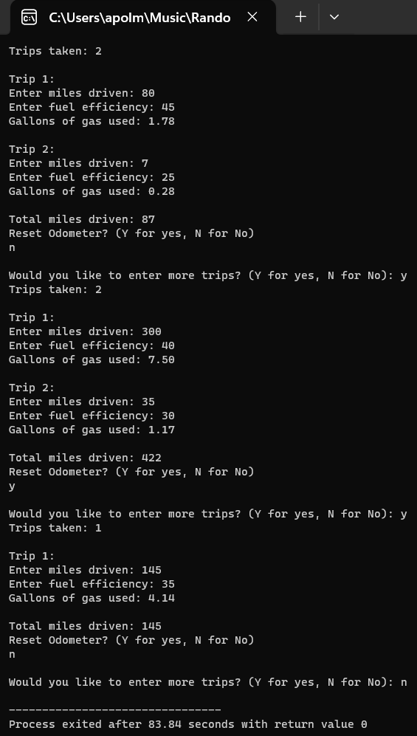

3. Write a program to assign passengers seats in an airplane. Assume a small
airplane with seat numbering as follows:
1 A B C D
2 A B C D
3 A B C D
4 A B C D
5 A B C D
6 A B C D
7 A B C D
The program should display the seat pattern, with an X marking the seats
already assigned. For example, after seats 1A, 2B, and 4C are taken, the
display should look like this:
1 X B C D
2 A X C D
3 A B C D
4 A B X D
5 A B C D
6 A B C D
7 A B C D
After displaying the seats available, the program prompts for the seat desired, the user types in a seat, and then the display of available seats is updated. This continues until all seats are filled or until the user signals that the program should end. If the user types in a seat that is already assigned, the program should say that that seat is occupied and ask for
another choice. Ch7
//Apol Medrano HW8 Q3
#include <iostream>
#include <cctype>
#include <cstdlib>
using namespace std;

const int Index1_Size = 7;
const int Index2_Size = 4;

bool seatsOpen (char a[][Index2_Size]);
//searches if seats are open, if open return true
//if no spots are open, then return false
void intializeSeating (char a[][Index2_Size]);
//intializes array to simulate airplane seats
void outputSeating (char a[][Index2_Size]);
//outputs the current state of seating to the user
void findSeating (char a[][Index2_Size], int Loc1, char Loc2);
//takes in the location, checks if inputs are legal
//assigns passenger to input location, prints updated seating
int main()
{
char seating[Index1_Size][Index2_Size];
int Loc1;
char Loc2, ans;
intializeSeating (seating);
outputSeating (seating);
do
{
cout << "Enter the Row Number followed by Seat Letter"
<< " you wish to assign a passenger to: ";
cin >> Loc1 >> Loc2;
if (seatsOpen(seating) == true)
findSeating (seating, Loc1, Loc2);
else
{
cout << "All seats are taken. Ending Program.";
exit(1);
}
cout << "Would you like to assign a passenger to another seat? (Y for Yes, N for No)\n";
cin >> ans;
cout << endl;
} while ((ans == 'Y') || (ans == 'y'));
return 0;
}
bool seatsOpen (char a[][Index2_Size])
{
for (int i = 0; i < Index1_Size; i++)
{
for (int j = 0; j < Index2_Size; j++)
{
if (a[i][j] != 'X')
{
return (true);
}
}
}
return (false);
}
void intializeSeating (char a[][Index2_Size])
{
for (int i = 0; i < Index1_Size; i++)
{
a[i][0] = 'A';
a[i][1] = 'B';
a[i][2] = 'C';
a[i][3] = 'D';
}
}
void outputSeating (char a[][Index2_Size])
{
for (int i = 0; i < Index1_Size; i++)
{
cout << i+1 << " ";
for (int j = 0; j < Index2_Size; j++)
cout << a[i][j] << " ";
cout << endl;
}
cout << endl;
}
void findSeating (char a[][Index2_Size], int Loc1, char Loc2)
{
if (Loc1 < 1 || Loc1 > 7)
{
cout << "Invalid entry.\n\n";
return;
}
int ind1 = Loc1 - 1;
int ind2;

if (toupper(Loc2) == 'A')
ind2 = 0;
else if (toupper(Loc2) == 'B')
ind2 = 1;
else if (toupper(Loc2) == 'C')
ind2 = 2;
else if (toupper(Loc2) == 'D')
ind2 = 3;
else
{
cout << "Invalid entry.\n\n";
return;
}

if (a[ind1][ind2] == 'X')
{
cout << Loc1 << Loc2
<< " is already occupied.\n\n";
}
else
{
a[ind1][ind2] = 'X';
cout << "Seat is now occupied at "
<< Loc1 << Loc2 << ".\n\n";
}
cout << "Updated airplane seating:\n";
outputSeating (a);
return;
}
Q3 OUTPUT:
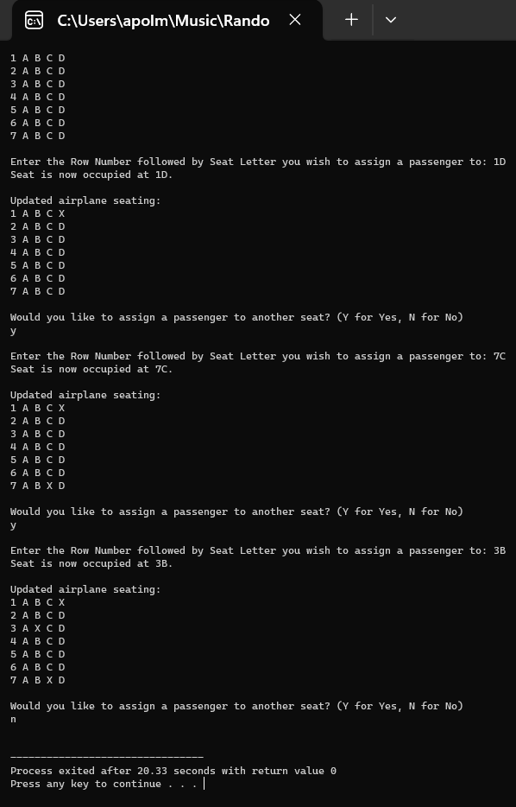

4. Create a class StringSet that will store a set of STL strings. The class will use a constructor that will take strings. Member functions should be: add string to set, remove a string from the set clear the entire set, return the number of strings in the set, and output all strings in the set. Ch11

//Apol Medrano HW8 Q4
#include <iostream>
#include <string>
#include <vector>
using namespace std;
//class that stores a set of STL strings
class StringSet
{
public:
StringSet ();
//intializes string set to have zero strings
StringSet (string newString);
//intializes string set to have 1 string
StringSet (string a[], int sizeOfString);
//intializes string set to have an array
//full of strings, multiple strings at once
void userPrompt ();
//gives user's a selection menu to choose
//what they wish to do with the stringList
private:
vector<string> stringList;
int size;
void addString ();
//adds string to set
void removeString ();
//removes string from set
void clearSet ();
//clears the set, so it is empty
void theSetSize ();
//returns the current size of String set
void outputSet ();
//outputs all strings within the set
};
int main()
{
string random[5] = {"Water is wet", "food", "word", "dog", "C++"};
StringSet listOfStrings(random, 5);
listOfStrings.userPrompt();
return 0;
}
StringSet :: StringSet ( )
{
stringList.clear();
size = 0;
}
StringSet :: StringSet (string newString)
{
stringList.push_back(newString);
size = 1;
}
StringSet::StringSet (string a[], int sizeOfString)
{
size = 0;
for (int i=0; i < sizeOfString; i++)
{
stringList.push_back(a[i]);
size++;
}
}
void StringSet :: userPrompt ()
{
int choice = 0;
while (choice != 6)
{
cout << "Select an Option\n"
<< "1. Add String to List\n"
<< "2. Remove String from List\n"
<< "3. Clear the entire String List\n"
<< "4. See String List size\n"
<< "5. Output entire String List\n"
<< "6. Quit\n"
<< "Selection: ";
cin >> choice;
switch(choice)
{
case 1:
cin.ignore();
addString();
break;
case 2:
removeString();
break;
case 3:
clearSet();
break;
case 4:
theSetSize();
break;
case 5:
outputSet();
break;
case 6:
return;
break;
default:
cout << "\nInvalid entry. Re-enter choice.\n\n";
break;
}
}
}
void StringSet :: addString ()
{
string newString;
char choice;
cout << "\nEnter the String you'd like to add:\n";
getline (cin, newString);
cout << "Would you like for it to be added? (Y for Yes, N for No)\n";
cin >> choice;
if ((choice == 'Y') || (choice == 'y'))
{
stringList.push_back(newString);
size ++;
}
cout << "Returning to Selection Menu.\n\n";
return;
}
void StringSet :: removeString ()
{
if (size == 0)
{
cout << "\nNothing to delete yet. Back to Selection Menu.\n\n";
return;
}
if (size == 1)
{
cout << "\nIf you want to delete already. Use clear instead.\n"
<< "Returning to Selection Menu.\n\n";
return;
}

int selection;
cout << "\nChoose what String row you'd like to delete.\n";
outputSet();
cout << "Enter row number to delete: ";
cin >> selection;
if (selection > size || selection < 0)
{
cout << "Invalid value. Returning to Selection Menu.\n\n";
return;
}
else if (selection == size)
{
stringList.pop_back();
size = size - 1;
cout << "Deletion completed.\n\n";
}
else
{
stringList.erase(stringList.begin() + selection-1);
size = size - 1;
cout << "Deletion completed.\n\n";
}
return;
}
void StringSet :: clearSet ()
{
char choice;
cout << "\nAre you sure you want to clear the List?\n"
<< "(Y for Yes or N for No)\n";
cin >> choice;
if ((choice == 'Y') || (choice == 'y'))
{
stringList.clear();
size = 0;
}
cout << "Returning to Selection Menu.\n\n";
return;
}
void StringSet :: theSetSize ()
{
cout << "\nThe size of the String List is "
<< size << " element(s) long.\n";
cout << "Returning to Selection Menu.\n\n";
return;
}
void StringSet :: outputSet ()
{
if (size == 0)
{
cout << "\nNothing to show yet. Back to Selection Menu.\n\n";
return;
}
cout << endl;
for (int i = 0; i < size; i++)
cout << i+1 << ". " << "\"" << stringList[i] << "\"" << endl;
cout << endl;

return;
}
Q4 OUTPUT:
